***Assignment 1***

Taking sample data and visualizing it.

**NBA Dataset:**

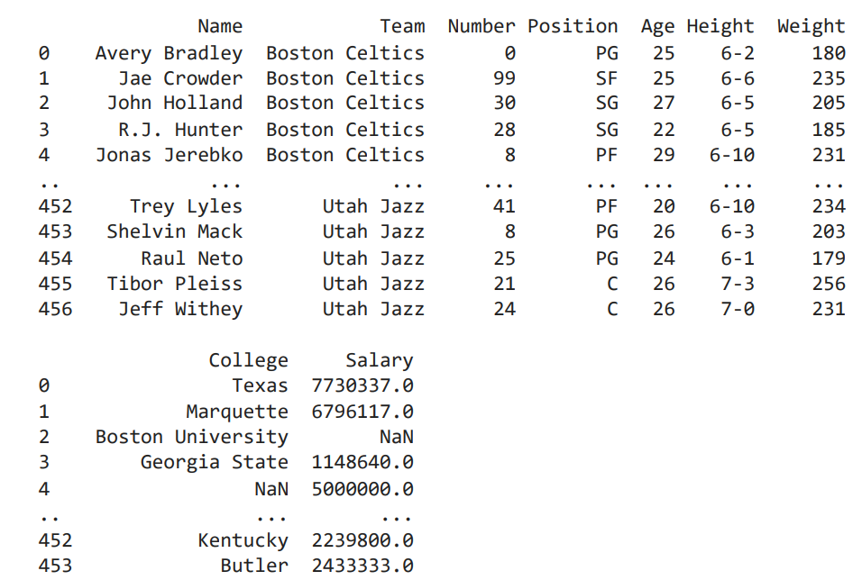

***Line Plot:***

sns.lineplot(x='Age',y='Weight',data=df,hue=data["Position"])

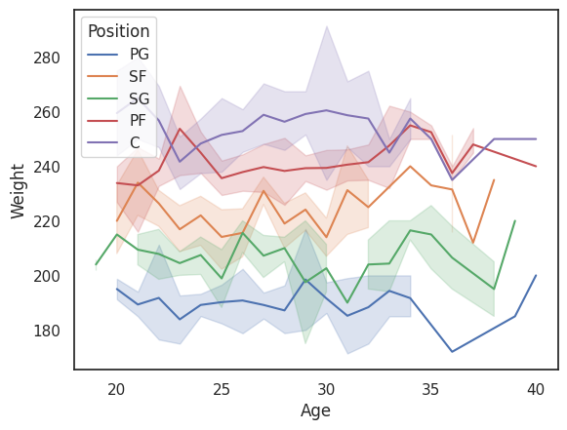

**Scatter Plot:**

sns.scatterplot(x='Age',y='Weight',data=df,hue=data["Position"])

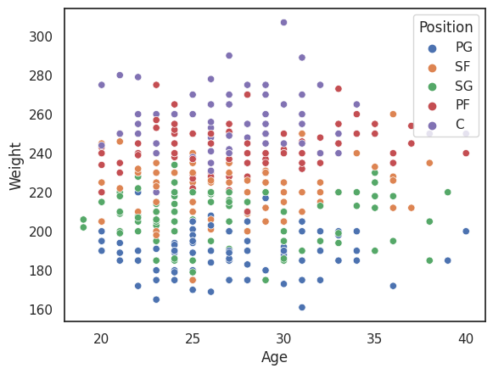

**Bar Plot:**

sns.barplot(x='Age',y='Weight',data=df)

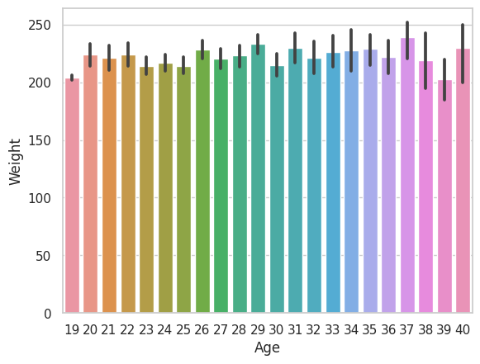

**Box Plot:**

sns.boxplot(x='Age',y='Weight',data=df)

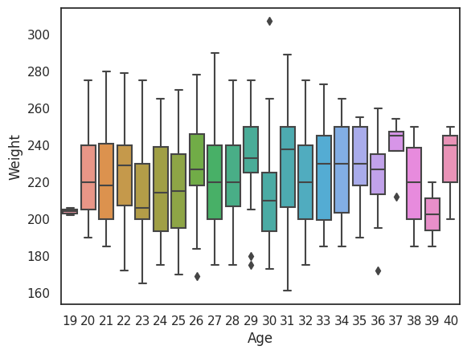

Pair Plot:

sns.pairplot(df)

